

OCTO, Ask VA VA.gov Team

(Debut Date) March XXX, 2025 | Ask VA Product Guide

Version 1

## Revision History

| Date | Version | Description | Author |
| --- | --- | --- | --- |
| 12/19/2024 | 1 | Product Debut | Tyler Gindraux  Ariel Martinez |
|  | 2 | (Describe changes, updates or additions) |  |
|  | 3 | (Describe changes, updates or additions) |  |

**Table of Conten**t**s**

1. Product Overview 4

2. User Access 5

2.1 Sign in to ask a question and read a reply from VA 5

2.2 If you only need general information, you may not have to sign in 5

3. Navigation 6

4. Functionality 7

4.1 Overview of user journeys 7

4.2 User story #1: As a Veteran, I would like to ask a question about how to access my life insurance policy online. 8

4.3 User Story #2: As a family member, I would like to ask a question on behalf of a Veteran about their care at a local VA medical center. 18

4.4 User Story #3: As a Work Study Site Supervisor, I would like to submit a timesheet on behalf of a Veteran as part of my job. 23

4.5 User Story #4: As an Accredited representative, I would like to read VA’s reply to my question about burials in a national cemetery. 26

5. Major Issues and Error Messages 32

5.1 Field errors 32

5.2 Failure upon submission 32

5.3 System downtime 34

Table of Figures 38

## 1. Product Overview

Ask VA (AVA) is a digital support channel for Veterans, family members and other submitters. People can use Ask VA to ask a question about education benefits, disability compensation, health care and many other topics. This online form takes about 2 to 15 minutes to complete.

If a user has a specific question about themselves, a family member, or another Veteran, they need to sign in. For general information about VA benefits and services, they can use the chatbot or find answers in our FAQs instead.

A user will provide information and answer a series of questions in order to submit a question to VA. Their question will be sent to an agent at VA from a specific business line, or department at VA, depending on the subject of their question. They should receive a reply from VA within 7 business days.

Ask VA should only be used for non-urgent needs:

* If someone is in a crisis or having thoughts of suicide, they should contact the Veterans Crisis Line.
* If their life is in danger, they should call 911 or go to the nearest emergency room.

In March 2025, Ask VA launched on VA.gov at [va.gov/contact-us/ask-va](http://va.gov/contact-us/ask-va). Before then, it was a stand alone Microsoft portal at [ask.va.gov](http://ask.va.gov).

## 2. User Access

### 2.1 Sign in to ask a question and read a reply from VA

Users need to sign in with an identity-verified (LOA3) account to ask a question about themselves, a family member or another Veteran. (Refer to Figure 1.) This is so we can communicate with them securely.

Signing in also lets them track their question and read a reply on VA.gov when it’s ready.

### 2.2 If you only need general information, you may not have to sign in

There are some general questions people can ask without signing in. (Refer to Figure 1.)

If we learn that someone’s question is about themselves, a family member or another Veteran, we will ask them to start over and sign in.

If they submit their question without signing in, we will communicate with them through email only. They will not be able to track their question and read a reply on VA.gov.

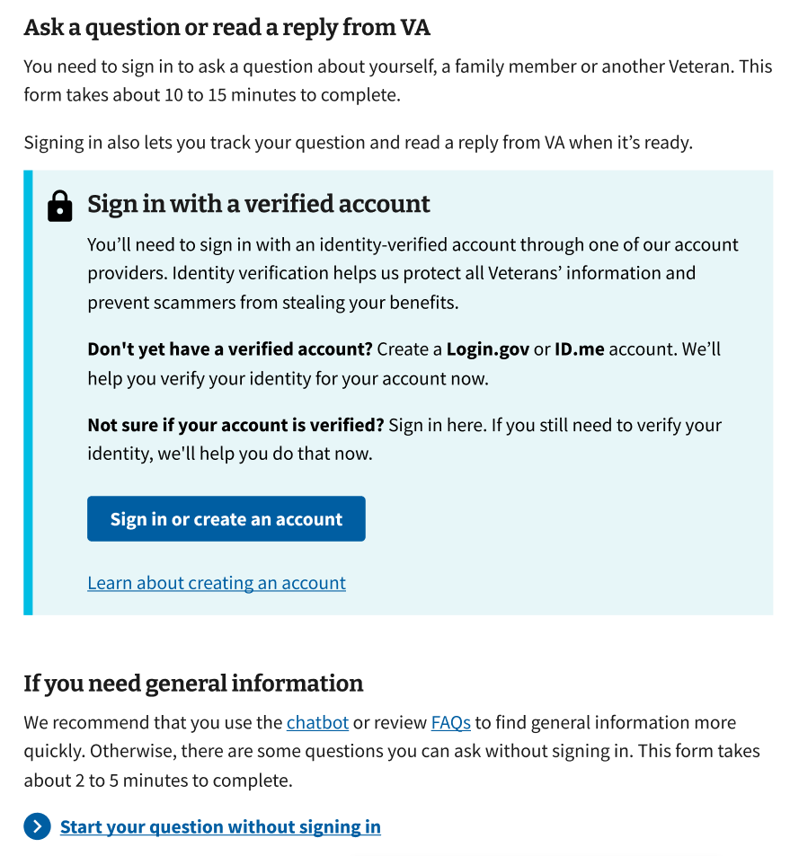

*Figure 1. Choose whether to sign in or not.*

## 3. Navigation

Ask VA is located at [va.gov/contact-us/ask-va](http://va.gov/contact-us/ask-va). It’s nested under [Contact Us](https://www.va.gov/contact-us/) on VA.gov. (Refer to Figure 2.)

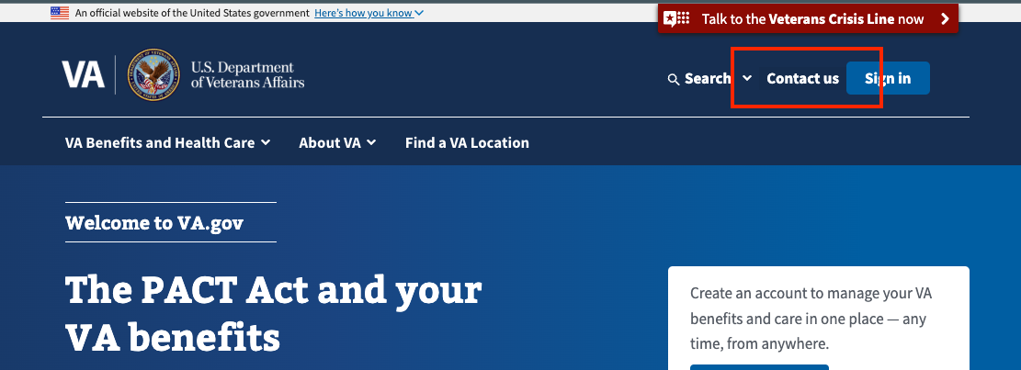

*Figure 2. Contact us on VA.gov.*

People might also navigate to Ask VA from a content page within the benefits hub, for example, [VA education and training benefits](https://www.va.gov/education/) links to Ask VA for further help. (Refer to Figure 3.)

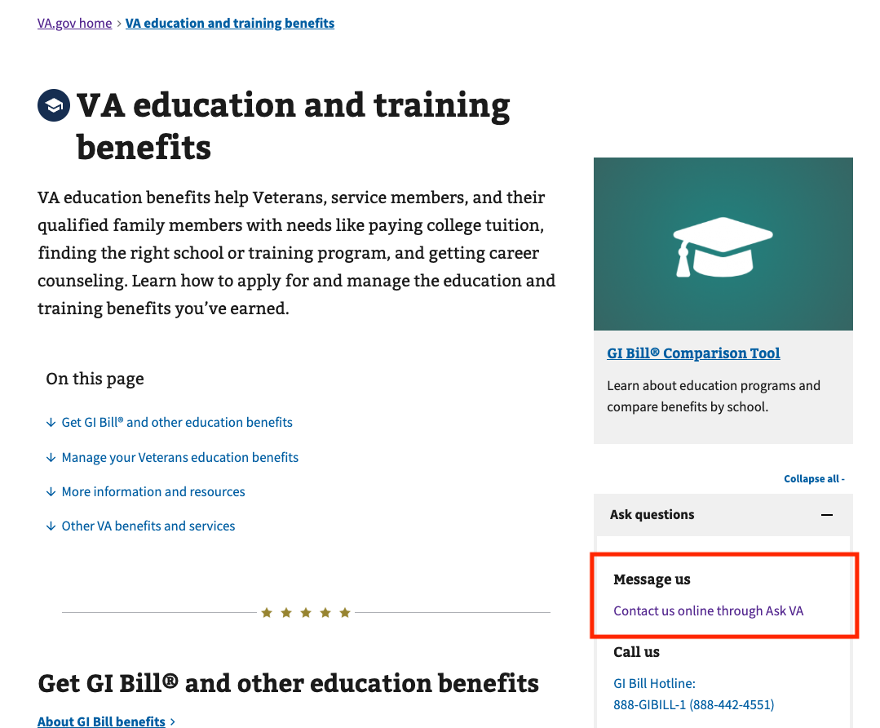

*Figure 3. Link to Ask VA from VA education and training benefits page.*

## 4. Functionality

### 4.1 Overview of user journeys

Ask VA includes many different user journeys, which depend on:

* who the user is (e.g. a Veteran, a family member or connected to a Veteran through their work)
* who they’re asking a question about
* what topic their question is about

This means Ask VA contains many conditional questions, or questions that will only appear under certain circumstances.

We will describe the following user stories as examples, but keep in mind that Ask VA covers many additional scenarios:

1. As a Veteran, I would like to ask a question about how to access my life insurance policy online. (Jump to User Story #1.)
2. As a family member, I would like to ask a question on behalf of a Veteran about their care at a local VA medical center. (Jump to User Story #2.)
3. As a Work Study Site Supervisor, I would like to submit a timesheet on behalf of a Veteran. (Jump to User Story #3.)
4. As an Accredited representative, I would like to read VA’s reply to my question about burials in a national cemetery. (Jump to User Story #4).

### 4.2 User story #1: As a Veteran, I would like to ask a question about how to access my life insurance policy online.

In this scenario, a user will follow the journey in Figure 4 and described in detail below.

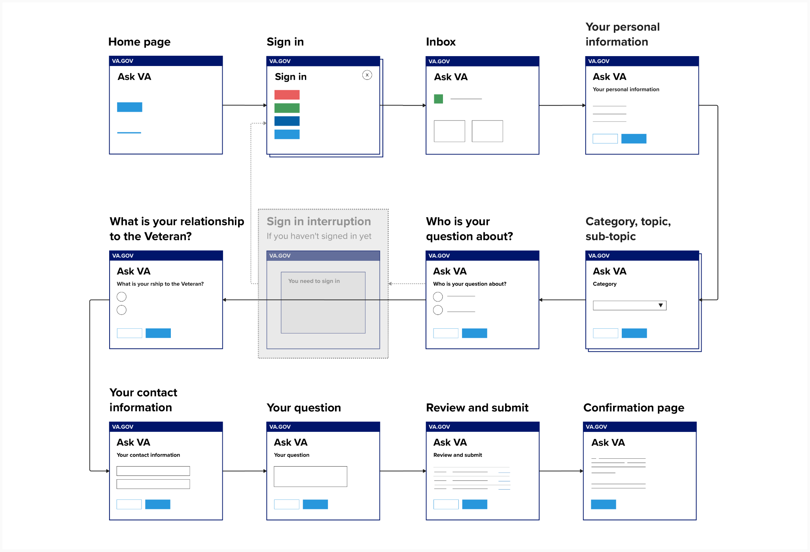

*Figure 4. User journey for user story #1.*

#### Steps

1. First, they will navigate to Ask VA.
2. Next, they will choose whether to sign in or not. In this scenario, if they choose to start without signing in, they will be forced to sign in and start over later on. Ideally, they will choose to sign in before they begin. (Refer to Figure 1.)
3. After signing in, they will land on their Ask VA inbox. This is where they can review past questions they have asked the VA through Ask VA. To continue asking this question about their life insurance policy, they will click, ‘Ask a new question.’ (Refer to Figure 5.)

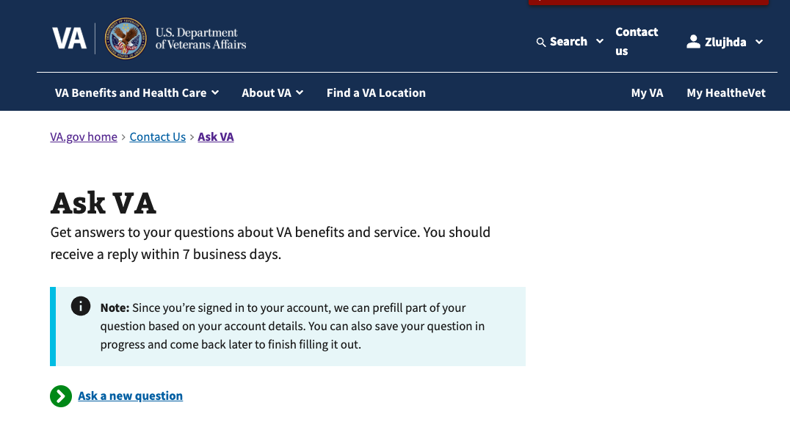

*Figure 5. After you sign in, you click ‘Ask a new question’ to start.*

1. Next, they will review their personal information, which includes their name, Social Security number and date of birth. This is pre-filled from VA Profile when they sign in. (Refer to Figure 6.)

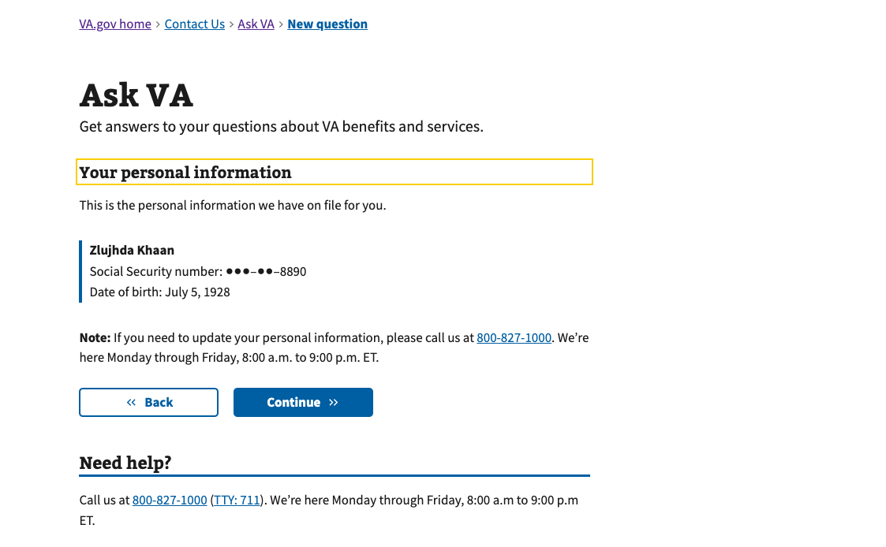

*Figure 6. ‘Your personal information’ is pre-filled from VA Profile if you sign in.*

1. Next, they will choose a category that best describes their question. In this example, ‘Life insurance’ is most relevant. Then, they will choose a topic that best describes their question. In this example, ‘Accessing policy online’ is most relevant. Sometimes, but not always, they will also choose a subtopic. (Refer to Figure 7.)

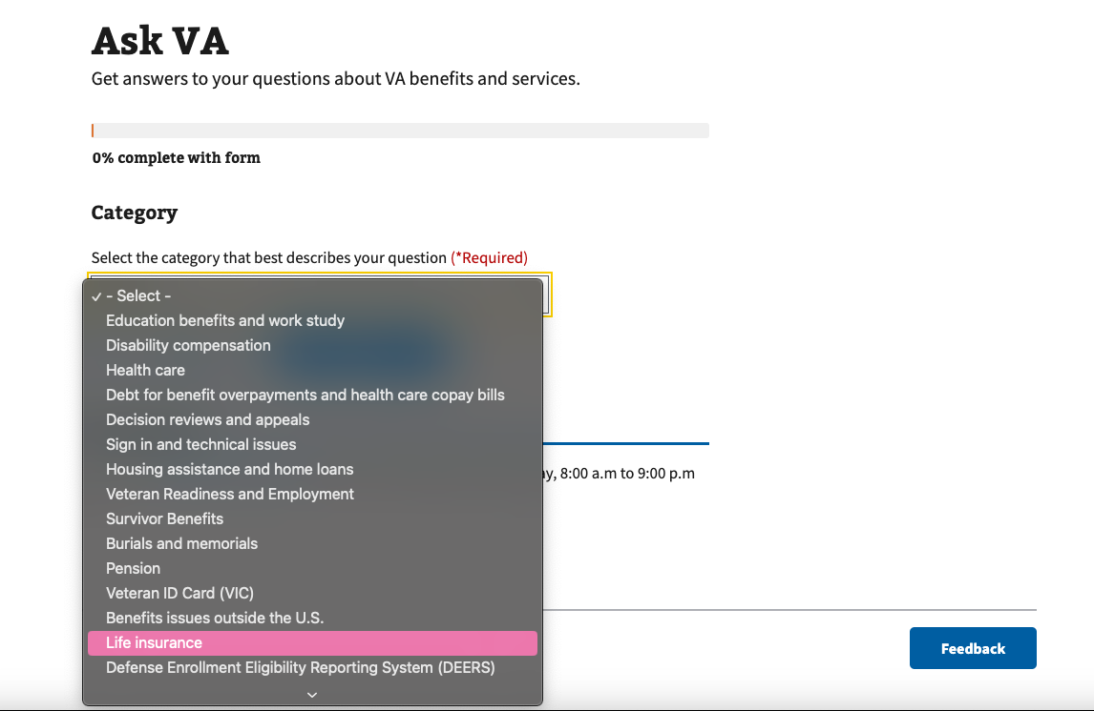

*Figure 7. Choose a category, topic, and sometimes also a subtopic, to describe your question.*

1. Next, they will choose who their question is about. In this example, their question is about themselves, so they will choose, ‘Myself.’ (Refer to Figure 8.)

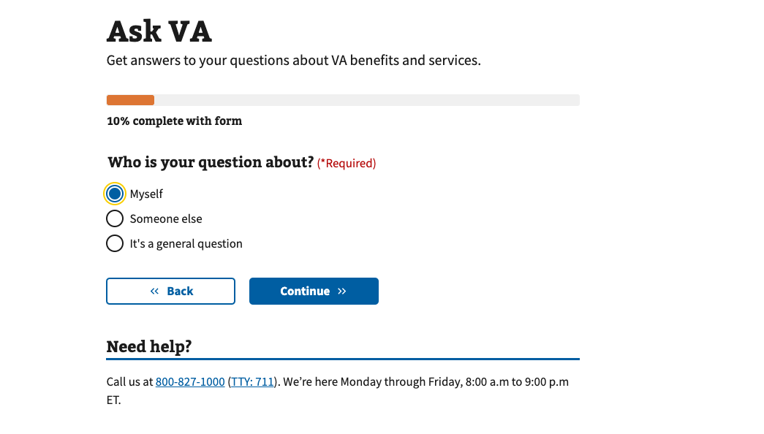

*Figure 8. Choose who your question is about.*

1. At this point, if they had not already chosen to sign in during Step 2, they would be asked to sign in. This is because their question is about themselves and not a general question. When this happens, they have to start over. (Refer to Figure 9.)

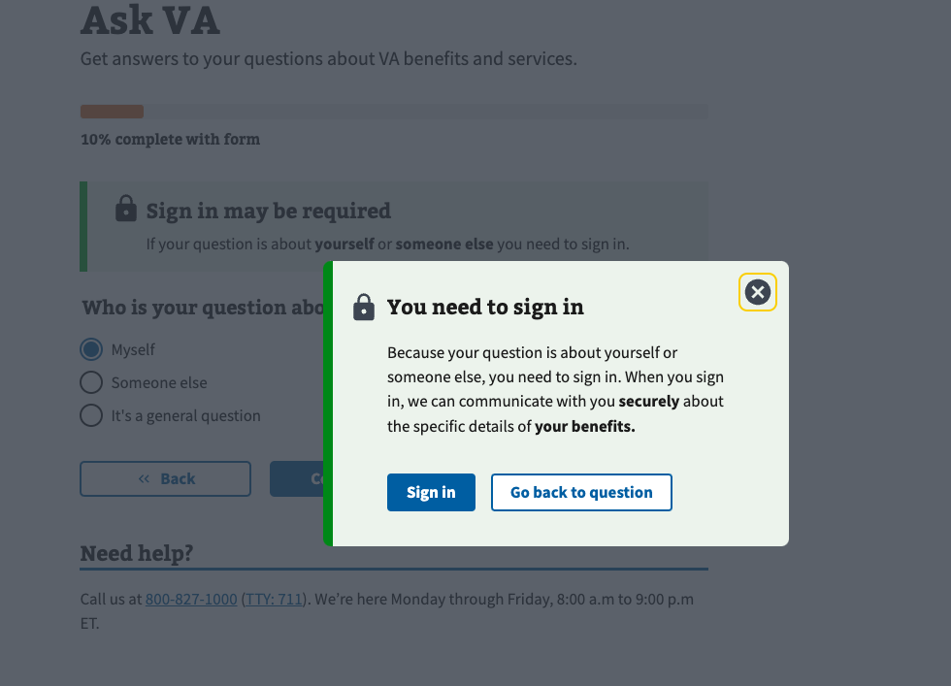

*Figure 9. Sign in modal will interrupt you if you need to sign in.*

1. Next, they will choose their relationship to the Veteran. In this example, they will choose, ‘I’m the Veteran.’ (Refer to Figure 10.)

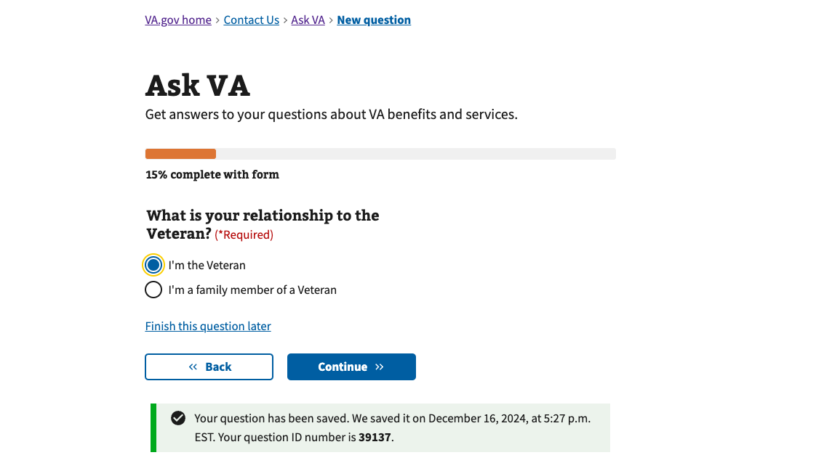

*Figure 10. Choose your relationship to the Veteran from two options.*

1. Next, they will share their contact information. Some information may be pre-filled from VA Profile because they’re signed in. (Refer to Figure 11.)

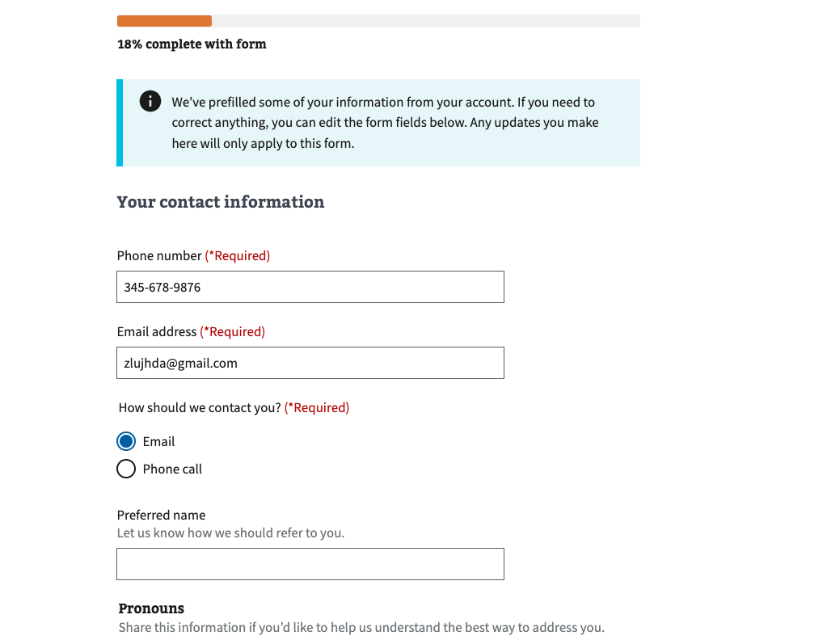

*Figure 11. Fill in or edit your contact information.*

1. Next, they will describe their question. In this example, they will describe the issues they’re having accessing their life insurance policy online. Sometimes, like in this example, they will be allowed to upload a document with their question. When they have the option to upload a document, it’s completely optional. (Refer to Figure 12.)

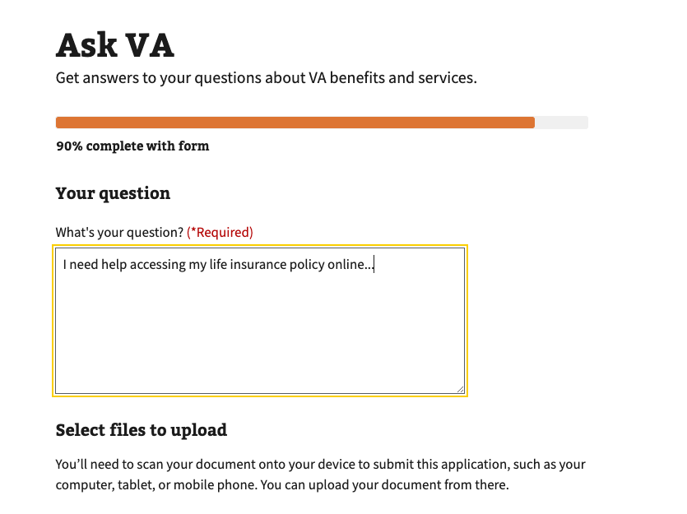

*Figure 12. Fill in your question and, sometimes, upload a file.*

1. Lastly, they will review the information they’ve input in the form. They will be able to edit some answers but not all answers. This is because editing some answers will change conditional questions in the form. If they need to change something they cannot edit, they need to click ‘Back’ to return to that page in the form. When they finish reviewing their answers, they click submit. (Refer to Figure 13.)

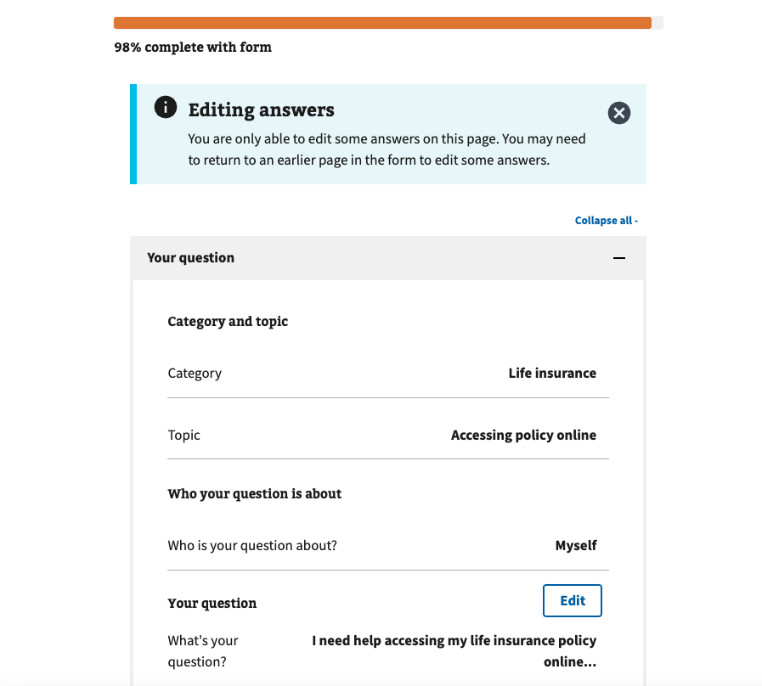

*Figure 13. Review and edit your responses before you submit.*

1. They will receive a reference number when their question is submitted. They can choose to return to the Ask VA inbox, complete another task on VA.gov or exit. (Refer to Figure 14.)

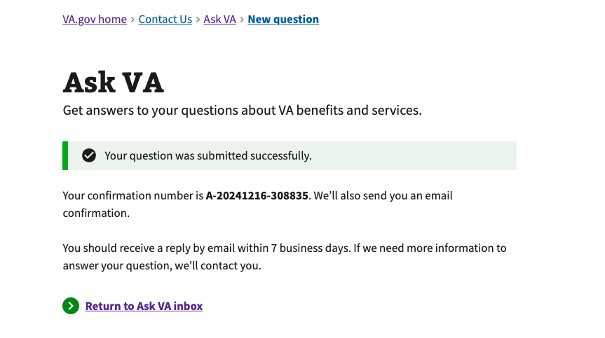

*Figure 14. After you submit successfully, you review a confirmation number.*

### 

### 4.3 User Story #2: As a family member, I would like to ask a question on behalf of a Veteran about their care at a local VA medical center.

In this scenario, a user will follow the journey in Figure 15 and described in detail below.

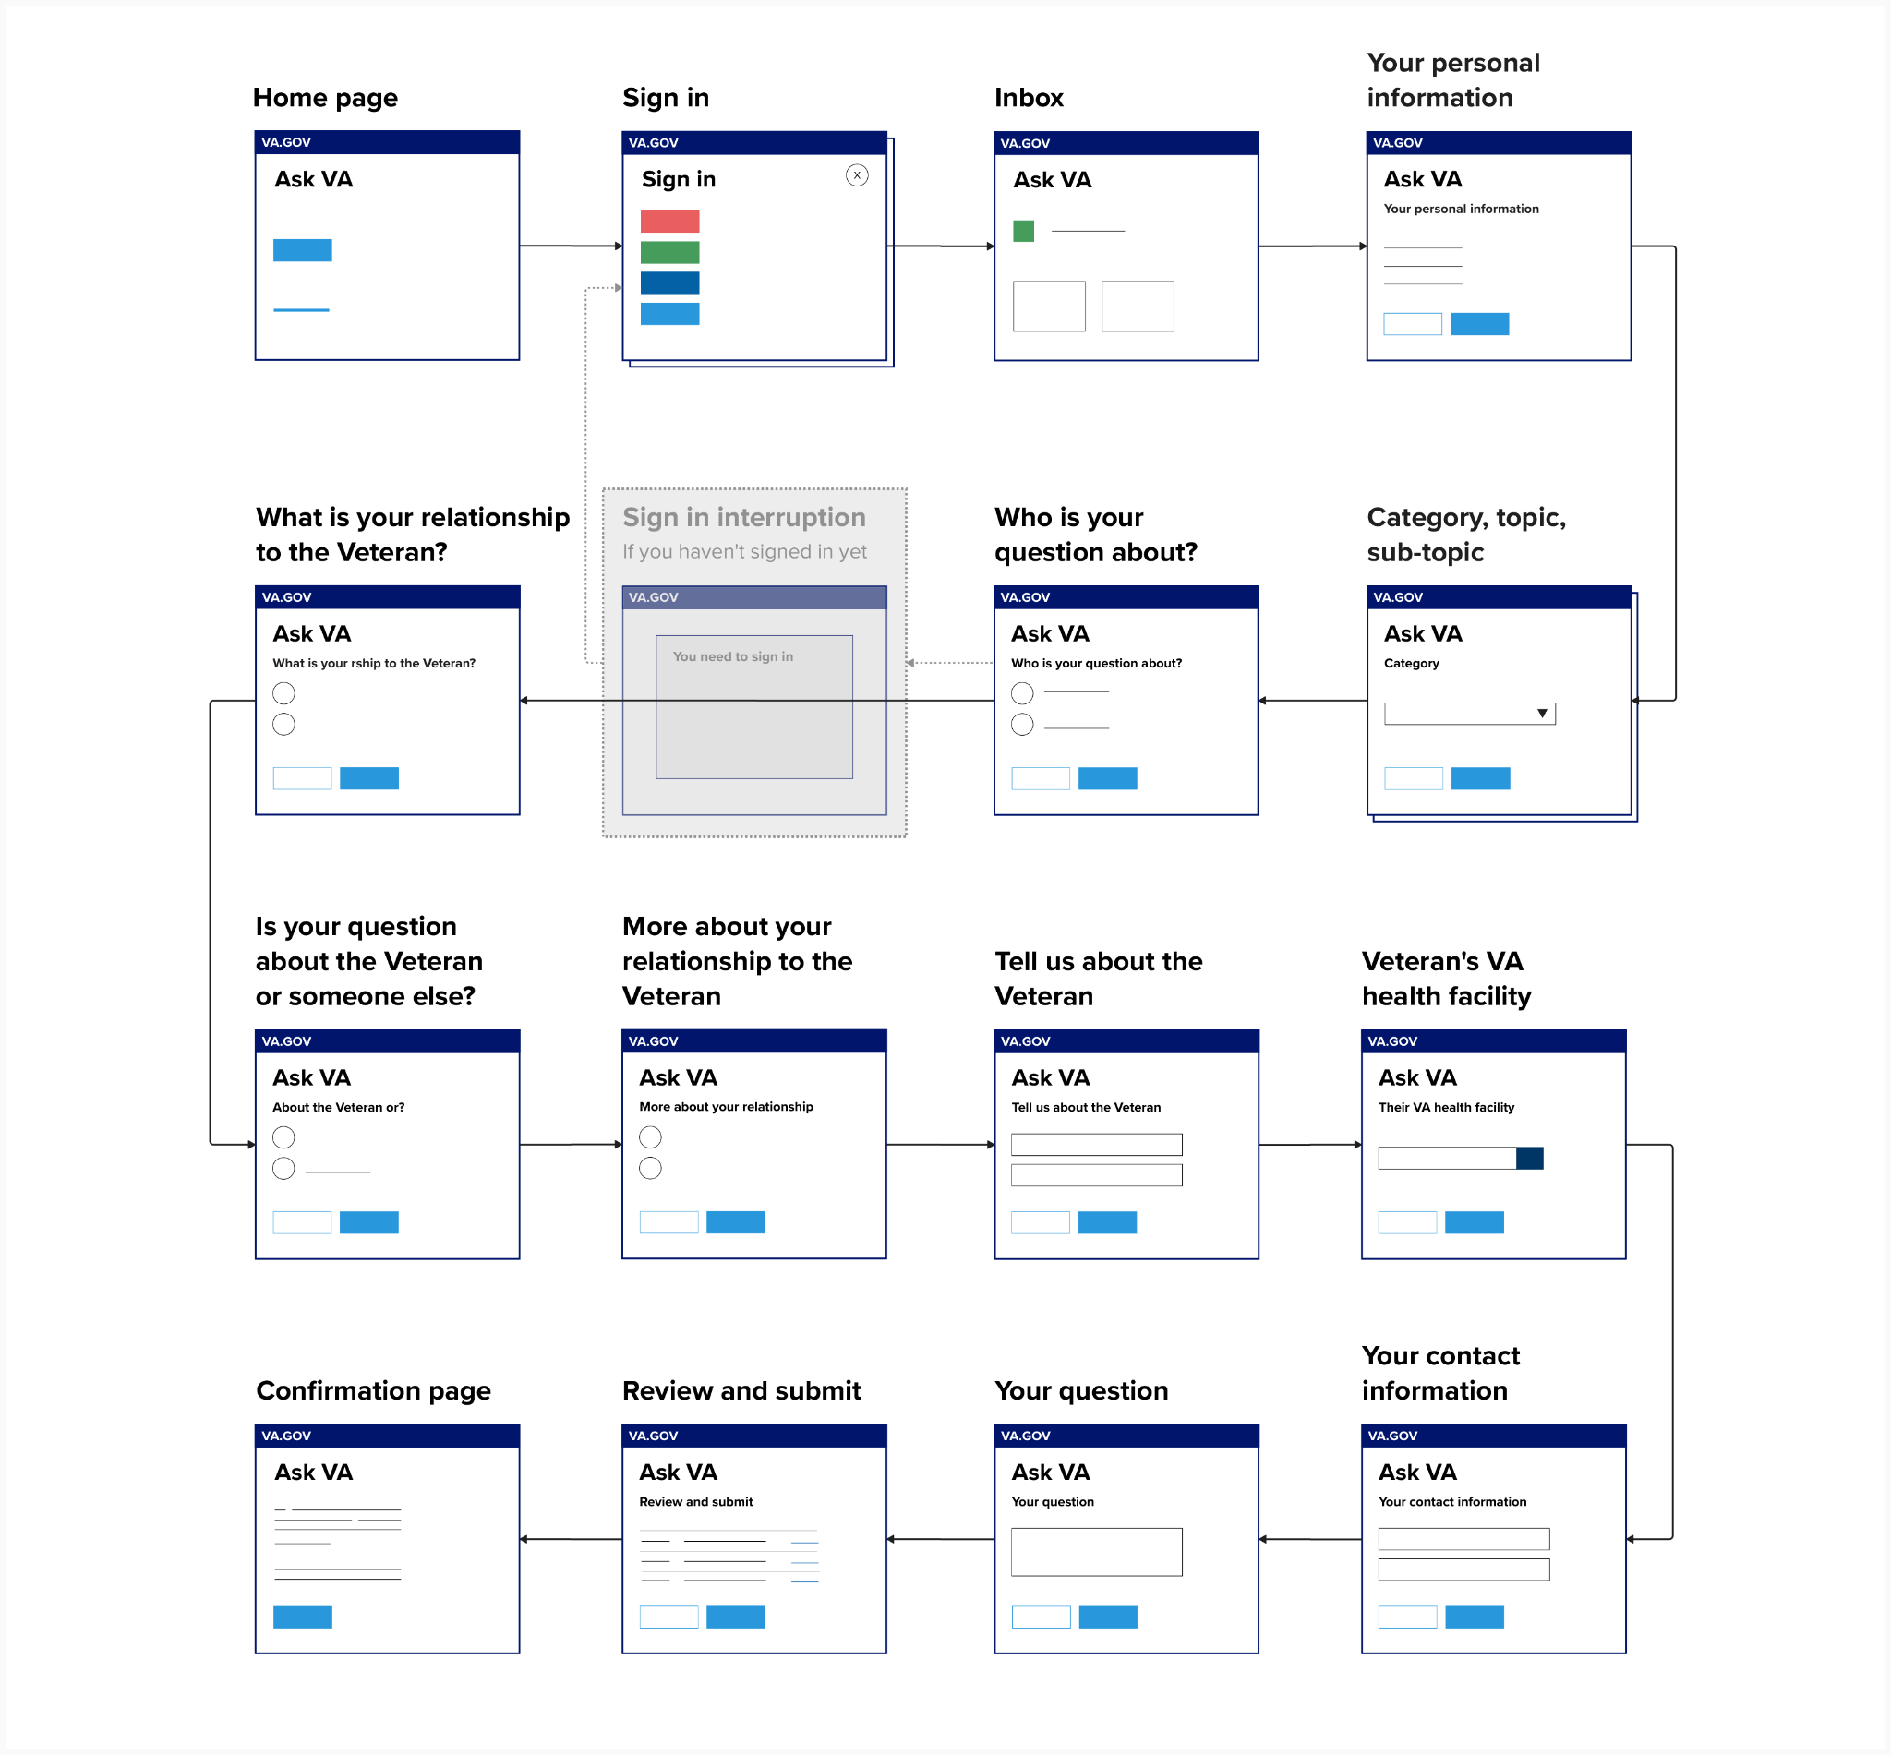

*Figure 15. User journey for user story #2.*

#### Steps

1. First, they will navigate to Ask VA.
2. Next, they will choose whether to sign in or not. In this scenario, if they choose to start without signing in, they will be forced to sign in and start over later on. Ideally, they will choose to sign in before they begin. (Refer to Figure 1.)
3. After signing in, they will land on their Ask VA inbox. This is where they can review past questions they have asked the VA through Ask VA. To continue asking this question about their Veteran’s health care, they will click, ‘Ask a new question.’ (Refer to Figure 5.)
4. Next, they will review their personal information, which includes their name, Social Security number and date of birth. This is pre-filled from VA Profile when they sign in. (Refer to Figure 6.)
5. Next, they will choose a category that best describes their question. In this example, ‘Health care’ is most relevant. Then, they will choose a topic that best describes their question. In this example, ‘Getting care at a local VA medical center’ is most relevant. Sometimes, but not always, they will also choose a subtopic. (Refer to Figure 7.)
6. Next, they will choose who their question is about. In this example, their question is about, ‘Someone else.’ (Refer to Figure 8.)
7. At this point, if they had not already chosen to sign in during Step 2, they would be asked to sign in. This is because their question is about someone else and not a general question. When this happens, they have to start over. (Refer to Figure 9.)
8. Next, they will choose their relationship to the Veteran. In this example, they will choose, ‘I’m a family member of a Veteran.’ (Refer to Figure 16.)

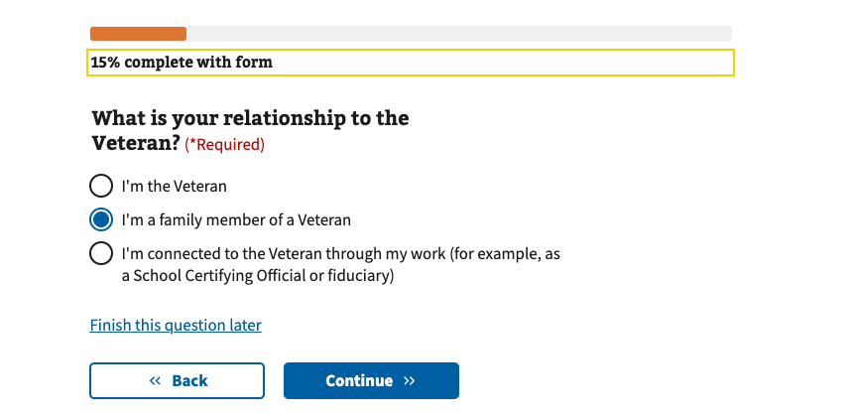

*Figure 16. Choose your relationship to the Veteran from three options.*

1. Next, they are asked whether their question is about the Veteran or someone else. In this example, they will choose, ‘Veteran.’ (Refer to Figure 16.)

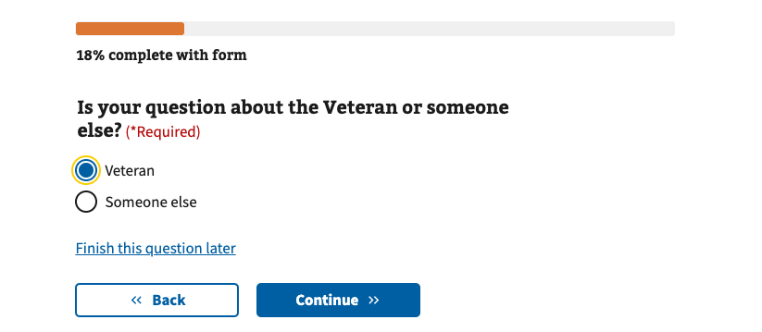

*Figure 17. Specify who your question is about.*

1. Then, they will provide more information about their relationship to the Veteran. In this example, they can say they’re the Veteran’s spouse. (Refer to Figure 17.)

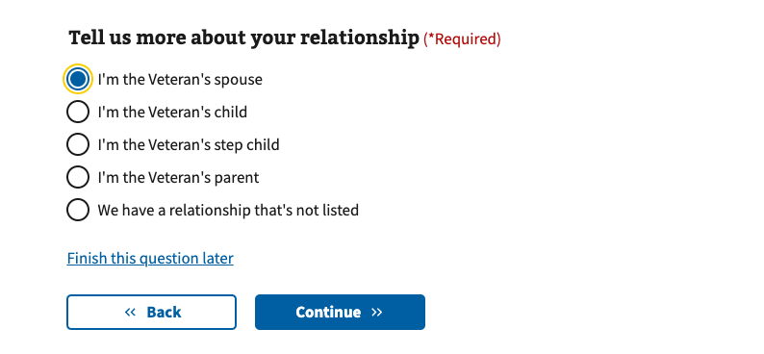

*Figure 18. Specify your relationship to the Veteran.*

1. Next, they will need to provide required information about the Veteran. This includes their name, Social Security number or Service number, and their date of birth. (Refer to Figure 19.)

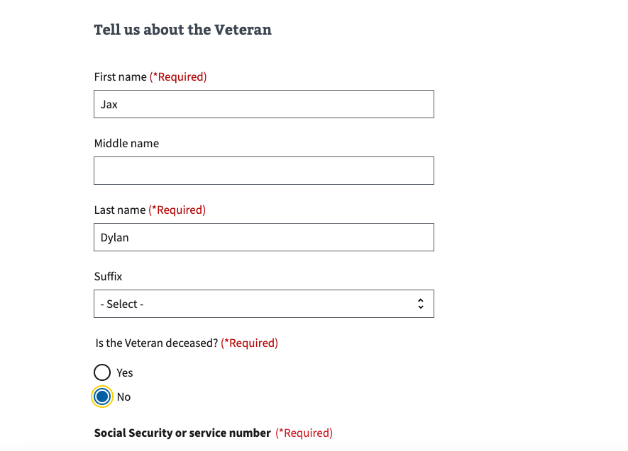

*Figure 19. Fill in information about the Veteran.*

1. Next, they will need to search for and choose the Veteran’s health facility. This is required information because their question, in this example, is related to the Veteran’s health care. (Refer to Figure 20.)

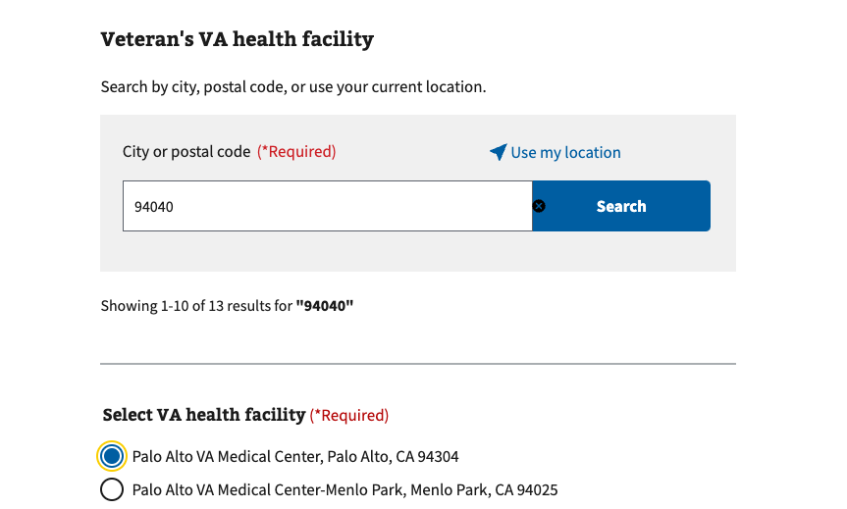

*Figure 20. Search for and select a VA health facility, before clicking continue.*

1. Next, they will share their contact information. Even though their question is about the Veteran and not themselves, they are still the person submitting the question and who VA will correspond with. This is why we ask for their contact information and not the Veteran’s. Some information may be pre-filled from VA Profile because they’re signed in. (Refer to Figure 11.)
2. Next, they will describe their question. In this example, they will describe the question they have about their Veteran’s care at a local VA medical facility. Sometimes they will be allowed to upload a document with their question, but not in this example. (Refer to Figure 12.)
3. Lastly, they will review the information they’ve input in the form. They will be able to edit some answers but not all answers. This is because editing some answers will change conditional questions in the form. If they need to change something they cannot edit, they need to click ‘Back’ to return to that page in the form. When they finish reviewing their answers, they click submit. (Refer to Figure 13.)
4. They will receive a reference number when their question is submitted. They can choose to return to the Ask VA inbox, complete another task on VA.gov or exit. (Refer to Figure 14.)

### 4.4 User Story #3: As a Work Study Site Supervisor, I would like to submit a timesheet on behalf of a Veteran as part of my job.

In this scenario, a user will follow the journey in Figure 21 and described in detail below.

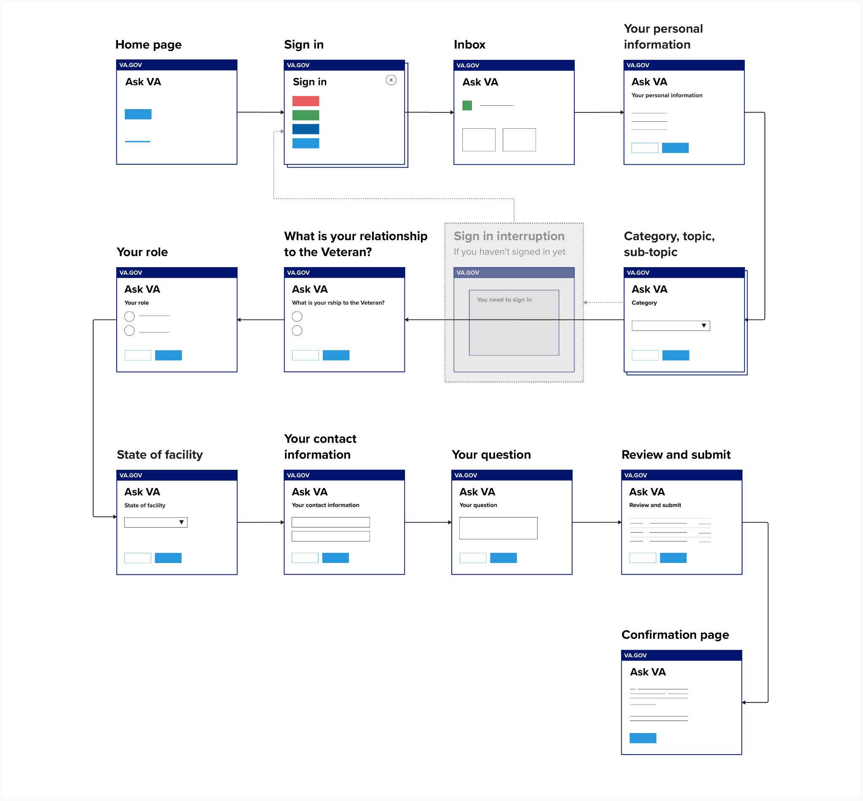

*Figure 21. User journey for user story #3.*

#### Steps

1. First, they will navigate to Ask VA.
2. Next, they will choose whether to sign in or not. In this scenario, if they choose to start without signing in, they will be forced to sign in and start over later on. Ideally, they will choose to sign in before they begin. (Refer to Figure 1.)
3. After signing in, they will land on their Ask VA inbox. This is where they can review past questions they have asked the VA through Ask VA. To continue asking this question, or in this case, submitting this timesheet on behalf of a Veteran, they will click, ‘Ask a new question.’ (Refer to Figure 5.)
4. Next, they will review their personal information, which includes their name, Social Security number and date of birth. This is pre-filled from VA Profile when they sign in. (Refer to Figure 6.)
5. Next, they will choose a category that best describes their question. In this example, ‘Education benefits and work study’ is most relevant. Then, they will choose a topic that best describes their question. In this example, ‘Work study’ is most relevant. Sometimes, but not always, they will also choose a subtopic. In this example, ‘Time card’ is most relevant. (Refer to Figure 7.)
6. At this point, if they had not already chosen to sign in during Step 2, they would be asked to sign in. This is because their question is about ‘Education benefits and work study,’ which requires them to sign in. When this happens, they have to start over. (Refer to Figure 9.)
7. Next, they will choose their relationship to the Veteran. In this example, they will choose, ‘I’m connected to the Veteran through my work.’ (Refer to Figure 16.)
8. Next, they will choose their role. In this example, they will choose, ‘Work study site supervisor.’ (Refer to Figure 22.)

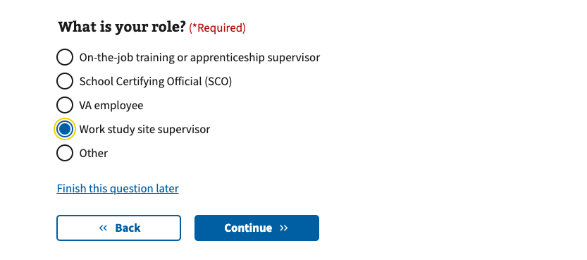

*Figure 22. Choose your role.*

1. Next, because of their role, they will be asked to select the state of their facility. This is the state where the facility they are supervising (as a Work study site supervisor) is located. (Refer to Figure 23.)

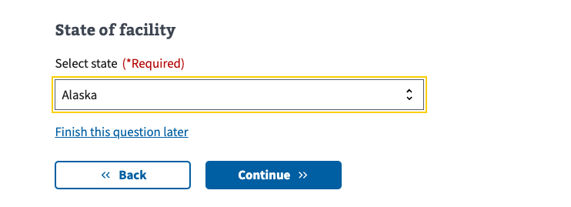

*Figure 23. Choose your state of facility.*

1. Next, they will share their contact information. Some information may be pre-filled from VA Profile because they’re signed in. (Refer to Figure 11.)
2. Next, they will describe their question. In this example, they will share some information about the timesheet and then upload the timesheet as a document. (Refer to Figure 12.)
3. Lastly, they will review the information they’ve input in the form. They will be able to edit some answers but not all answers. This is because editing some answers will change conditional questions in the form. If they need to change something they cannot edit, they need to click ‘Back’ to return to that page in the form. When they finish reviewing their answers, they click submit. (Refer to Figure 13.)
4. They will receive a reference number when their question is submitted. They can choose to return to the Ask VA inbox, complete another task on VA.gov or exit. (Refer to Figure 14.)

### 4.5 User Story #4: As an Accredited representative, I would like to read VA’s reply to my question about burials in a national cemetery.

In this scenario, a user will follow the journey in Figure 24 and described in detail below.

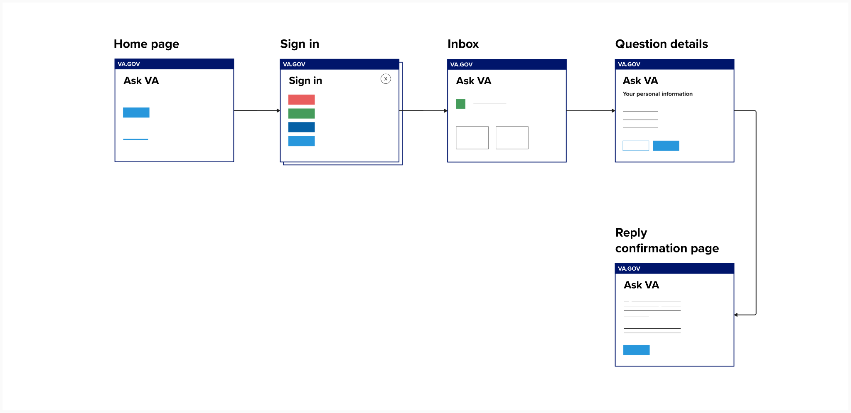

*Figure 24. User journey for user story #4.*

#### Steps

1. First, they will navigate to Ask VA.
2. Next, they will need to sign in. Users cannot read replies from VA on VA.gov without signing in. And if a user submits their question while signed in, they **must** sign back into VA.gov to read the reply from VA. (In contrast, if a user submits their question without signing in, they cannot track their question or reply from VA on VA.gov. All correspondence will happen over email, in this case.) (Refer to Figure 1.)
3. After signing in, they will land on their Ask VA inbox. This is where they can review past questions they have asked (while signed in). First, they should scroll down to where it says, ‘Your questions.’ (Refer to Figure 25.)

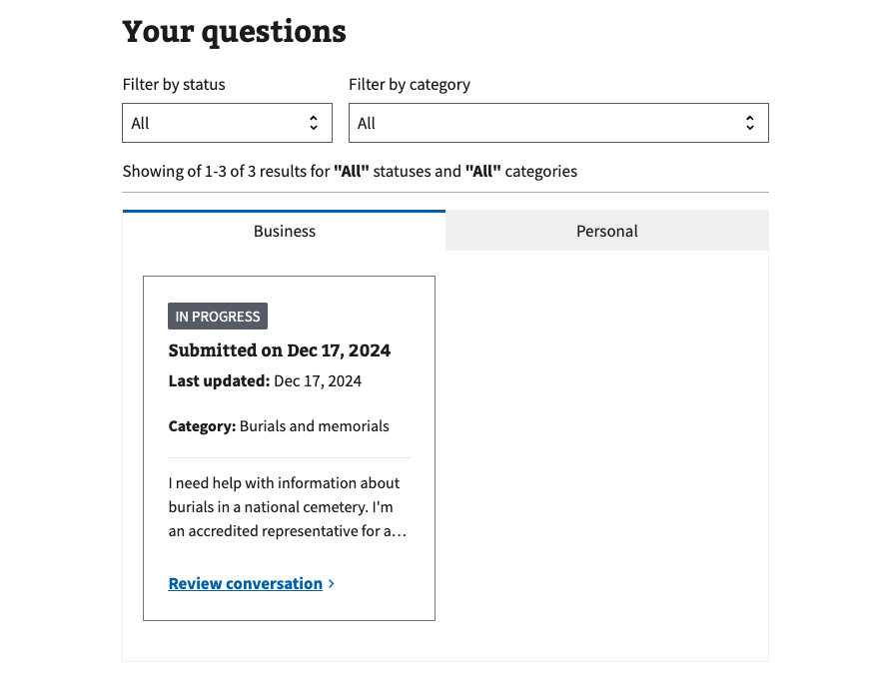

*Figure 25. Under ‘Your questions,’ you will find questions you have submitted to VA.*

1. Sometimes their inbox will have two tabs, like in Figure 25. The tabs will say, ‘Business’ and ‘Personal.’ This is because they have submitted **at least** **one** business question. A question is considered ‘business’ if they submit it and say that they’re ‘connected to the Veteran through work’ and share their role. If they have never submitted a business question, they will not have two tabs. This is because all of their questions are personal.
2. They can filter their questions by status. This will filter out any questions that have a status other than the one they selected. For example, if they choose ‘In progress’ then any questions with the status, ‘Replied’ or ‘Reopened,’ will not show up. (Refer to Figure 26.)

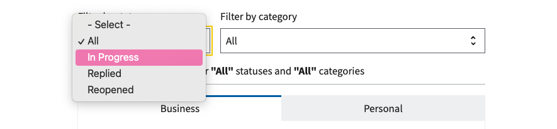

*Figure 26. Filter by status.*

1. They can also filter their question by category. This will filter out any questions that have a category other than the one they selected. For example, if they choose ‘Life insurance’ then any questions with a category other than ‘Life insurance’ will not show up. (Refer to Figure 27.)

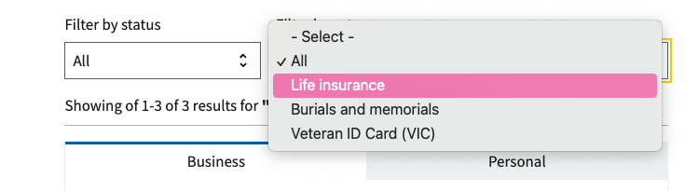

*Figure 27. Filter by category*

1. When they click ‘Review conversation’ on one of the cards in their inbox (Refer to Figure 25), they will navigate to the ‘Question details’ page. (Refer to Figure 28). If VA has replied to their question, the status will be ‘Replied.’ And under ‘Your conversation,’ they can navigate to the reply from VA by expanding the accordion or clicking the ‘plus’ symbol on the right. Here, they will read a reply from VA.

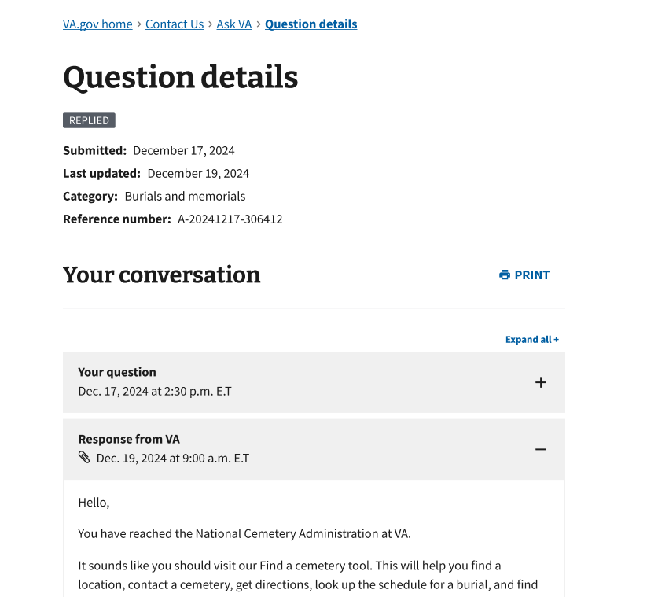

*Figure 28. Questions details page where you can read a reply from VA.*

1. At this point, if they decided they needed more information or have a follow up question for VA, they may have the option to reply back to VA. This is only available for some questions, because some business lines do not allow replies. If this is the case, they need to submit a new question. If they do have the option to send a reply, they will need to scroll down the ‘Question details’ page to the heading called, ‘Send a reply.’ Here, they can write a reply back to VA. (Refer to Figure 29.)

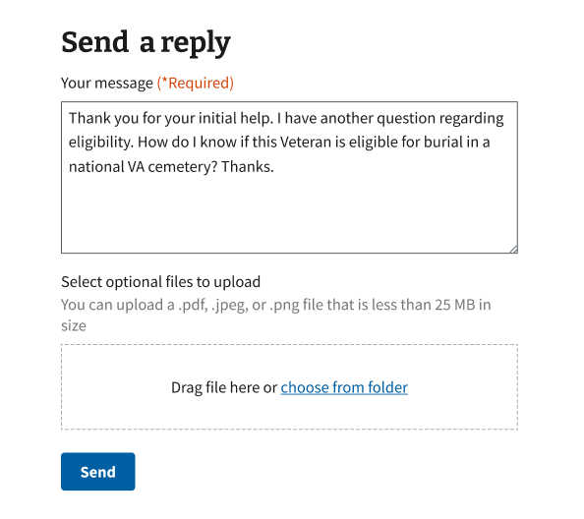

*Figure 29. Sometimes you have the option to send a reply back to VA.*

1. They will land on a confirmation page after they send their reply back to VA. Their question will be reopened and they will follow the same steps to read their reply from VA. They can choose to return to the Ask VA inbox, complete another task on VA.gov or exit. (Refer to Figure 30.)

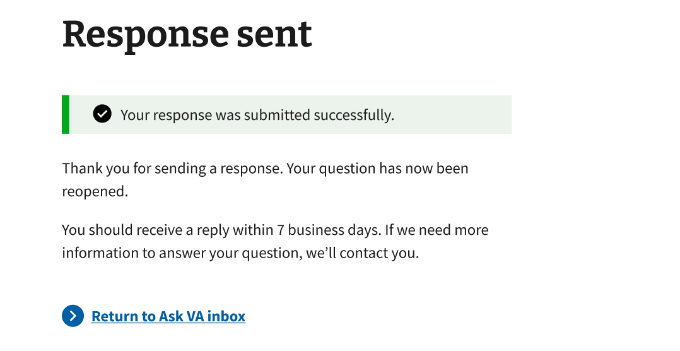

*Figure 30. After you send a reply to VA, your question will be reopened.*

## 5. Major Issues and Error Messages

### 5.1 Field errors

All required fields are marked required. If a user tries to continue without responding to a required field, they will receive a specific error message. For example, “Please enter an email address.” (Refer to Figure 31.)

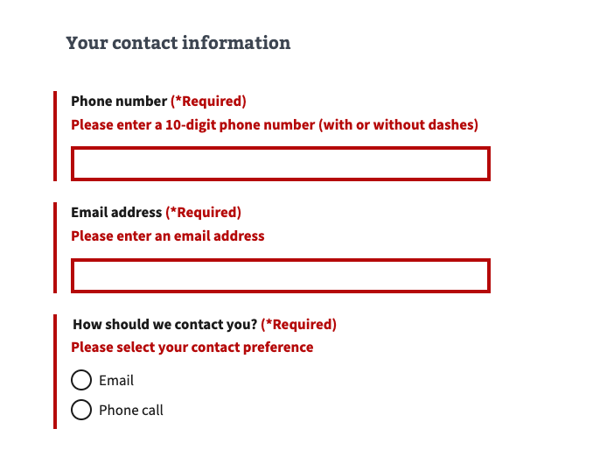

*Figure 31. Examples of field specific error messages.*

### 5.2 Failure upon submission

Sometimes, there will be a system issue when someone submits their question. If this happens, they receive a message asking them to try submitting their question again. They need to click the button, ‘Submit question’ to try again. (Refer to Figure 32.)

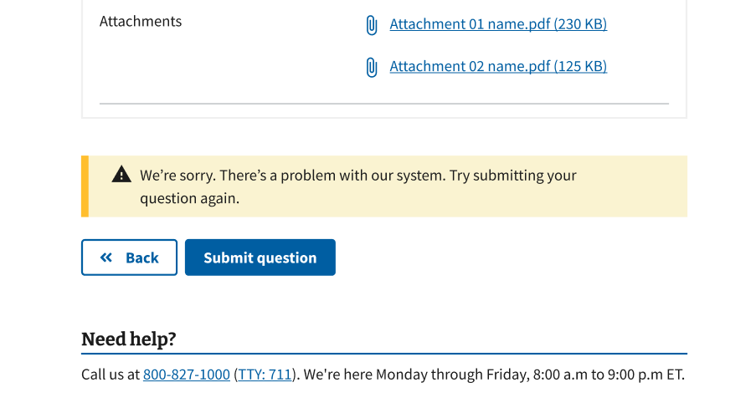

*Figure 32. First failure when submitting a question.*

If they try to submit their question again, and there’s still a problem, they will receive a message letting them know that Ask VA is not working right now. If they are signed in, we suggest that they try again later. Their question will be saved in their Ask VA inbox. (Refer to Figure 33.)

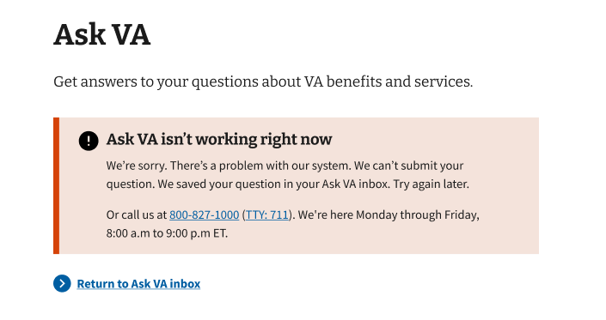

*Figure 33. Second failure when submitting a question while signed in.*

If they’re not signed in, their question is not saved in their Ask VA inbox. In this case, we suggest that they call VA to get help with their question. We share a record of their answers with them so you can reference this over the phone, or, if they come back to submit a new question later. (Refer to Figure 34.)

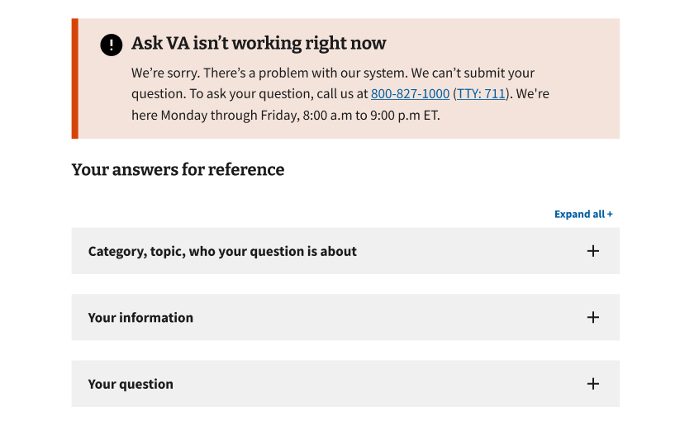

*Figure 34. Second failure when submitting a question while unauthenticated.*

### 5.3 System downtime

For scheduled downtime, we will provide a date and time when maintenance is expected to start and end. We will provide notice ahead of time and during the maintenance period. (Refer to Figure 35 and Figure 36.)

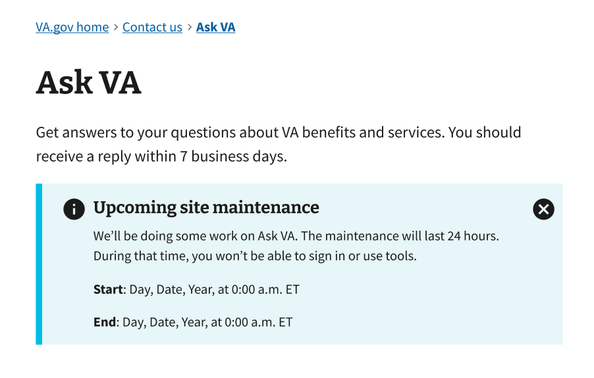

*Figure 35. Example of upcoming, scheduled site maintenance banner.*

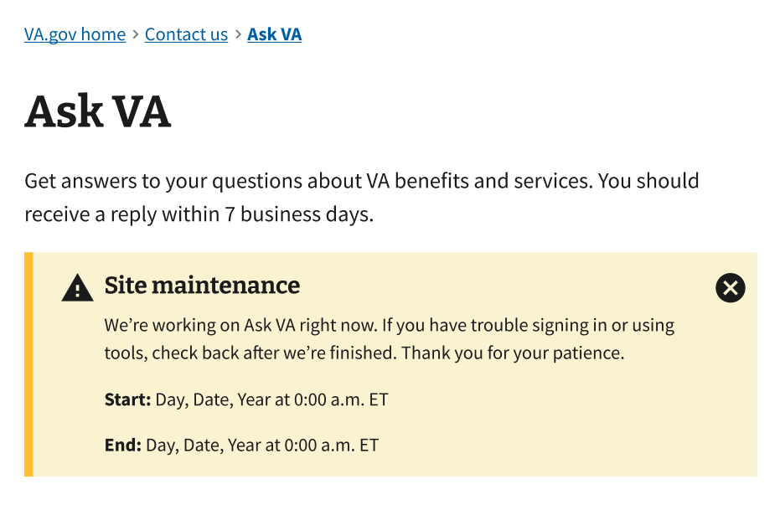

*Figure 36. Example of current, scheduled site maintenance banner.*

Sometimes, there may be partial downtime. For example, a feature of Ask VA is down but the rest of the service is working as normal. We will provide notice during this partial impact downtime. (Refer to Figure 37.)

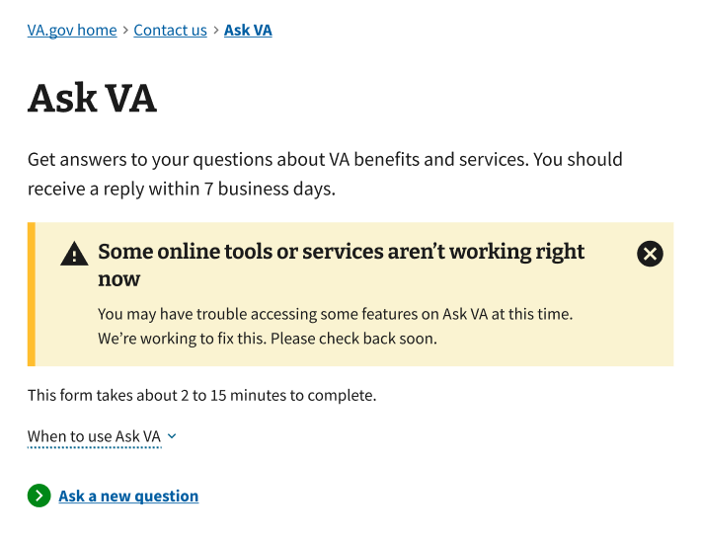

*Figure 37. Example of partial downtime banner.*

Rarely, there will be unscheduled downtime that causes Ask VA to be completely unavailable. We will notify users that the system is down for maintenance right now. (Refer to Figure 38.)

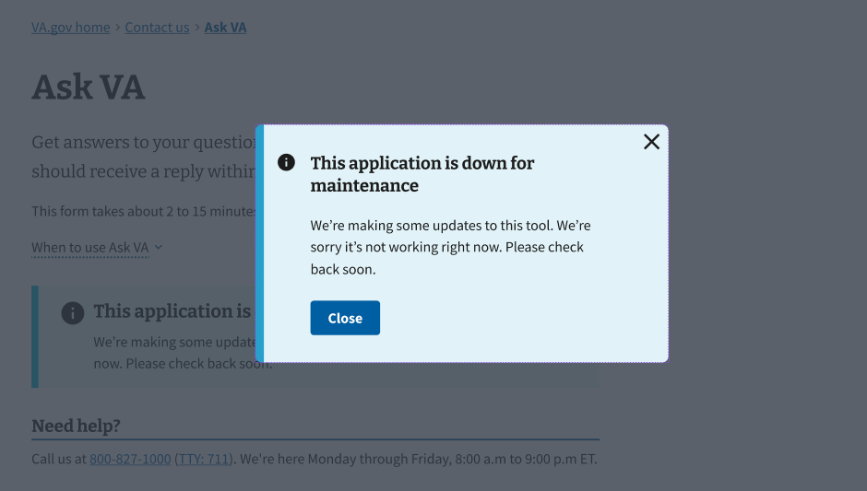

*Figure 38. Example of unscheduled downtime modal.*

## Table of Figures

Figure 1: Choose whether to sign in or not. 5

Figure 2: Contact us on VA.gov. 6

Figure 3: Link to Ask VA from VA education and training benefits page. 6

Figure 4: User journey for user story #1. 8

Figure 5: After you sign in, you click ‘Ask a new question’ to start. 9

Figure 6: ‘Your personal information’ is pre-filled from VA Profile if you sign in.  10

Figure 7: Choose a category, topic, and sometimes also a subtopic, to describe your question. 11

Figure 8: Choose who your question is about. 12

Figure 9: Sign in modal will interrupt you if you need to sign in. 12

Figure 10: Choose your relationship to the Veteran from two options. 13

Figure 11: Fill in or edit your contact information. 14

Figure 12: Fill in your question and, sometimes, upload a file. 15

Figure 13: Review and edit your responses before you submit. 16

Figure 14: After you submit successfully, you review a confirmation number. 17

Figure 15: User journey for user story #2. 18

Figure 16: Choose your relationship to the Veteran from three options. 19

Figure 17: Specify who your question is about. 20

Figure 18: Specify your relationship to the Veteran. 20

Figure 19: Fill in information about the Veteran. 21

Figure 20: Search for and select a VA health facility, before clicking continue. 22

Figure 21: User journey for user story #3. 23

Figure 22: Choose your role. 24

Figure 23: Choose your state of facility. 25

Figure 24: User journey for user story #4. 26

Figure 25. Under ‘Your questions,’ you will find questions you have submitted to VA. 27

Figure 26. Filter by status. 28

Figure 27. Filter by category. 28

Figure 28. Questions details page where you can read a reply from VA. 29

Figure 29. Sometimes you have the option to send a reply back to VA. 30

Figure 30. After you send a reply to VA, your question will be reopened. 31

Figure 31: Examples of field specific error messages. 32

Figure 32: First failure when submitting a question. 33

Figure 33: Second failure when submitting a question while signed in. 33

Figure 34: Second failure when submitting a question while unauthenticated. 34

Figure 35: Example of upcoming, scheduled site maintenance banner. 35

Figure 36: Example of current, scheduled site maintenance banner. 35

Figure 37: Example of partial downtime banner. 36

Figure 38. Example of unscheduled downtime modal. 37